**HOPE COMMUNITY HIGH SCHOOL - WAIRAKA**

**END OF TERM TWO ASSESSMENT**

**GEOGRAPHY 273/1**

**TIME ALLOWED: 1:45 MINUTES**

***INSTRUCTIONS***

* *All items carry equal marks*
* *Section A is compulsory and then choose one item from section A either from part I or part II*

**Section A compulsory**

**Item 1. Photographic Interpretation**

Study the photograph taken from one of the places in Uganda, and the text provided below it.

Uganda is one of the countries in East Africa with a variety of valuable mineral resources of gold, tin, copper, crude oil, limestone, phosphate among others. Of recent, there are many investors as seen in the photograph. The local communities have welcomed the program saying it would result to employment opportunities, high income to the people among others. However, the investors are well versed with the proper methods of mining to use in the extraction of minerals which can also help to protect the environment. The investors have organised a meeting with the local community and other stake holders to discuss the concerns. You have been invited to make a presentation.

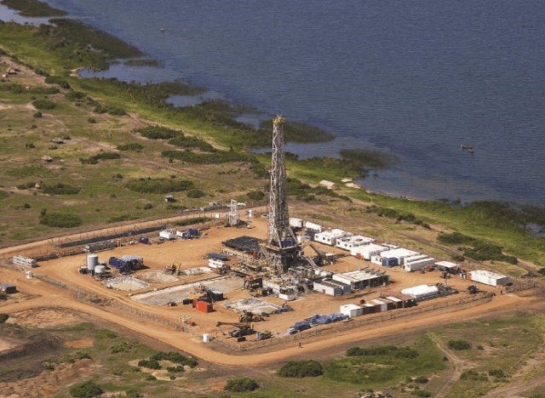

**Task**

1. Using relevant illustrations, mark and name the features found in the area shown in the photograph
2. Prepare a speech to be presented by the local leaders on behalf of local citizens in the meeting

**Section B**

**Part I (attempt one item in this part)**

**Item 2. Study the text below and Fig 4 provided below to answer the following task.** Many residents in the Ruwenzori region of western Uganda have various mythical explanations about the formation of Mt. Ruwenzori. Some elders believe it was created by ancestral gods, while others think it was formed when the moon came close to the Earth and raised part of the land. These myths have led to fear and misuse of the mountain. Some residents avoid using it, while others misuse it due to a false sense of protection from the gods, resulting in poverty and misery. You have been invited to a socio-economic workshop to educate residents about the existence of the mountain and its potential impact on their lives

**Support material.**

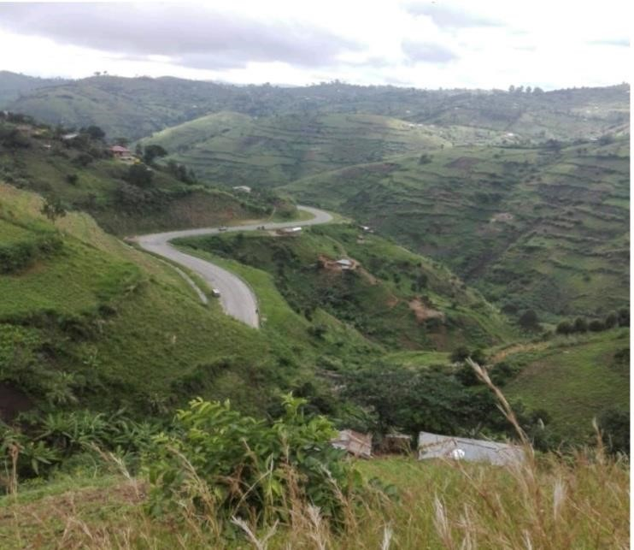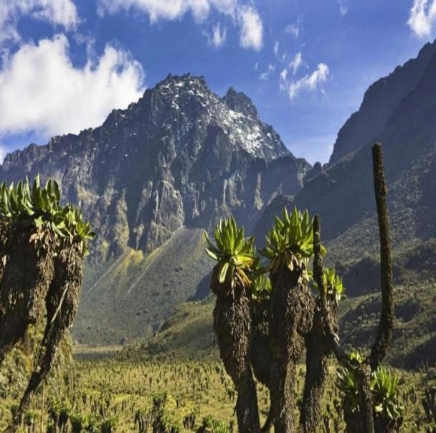

*Fig. 2(a) Upper view of Mt. Rwenzori. Fig.2 (b) Landscape view of lower Rwenzori.*

**Task.**

Prepare a descriptive speech for the residents of the Ruwenzori sub region to present at the workshop.

**Item 3**. The family of Mr. Were Danish has been living in Canada for the past 35 years. The family plans to return to Africa and establish their home in one of the relief regions where they can carry out modern animal rearing. However, they have little knowledge about the geography of Africa due to the fact that they have been actively engaging in activities in the foreign continent.

**Support material**

**A SKETCH AMP OF AFRICA SHOWING RELIEF REGIONS**

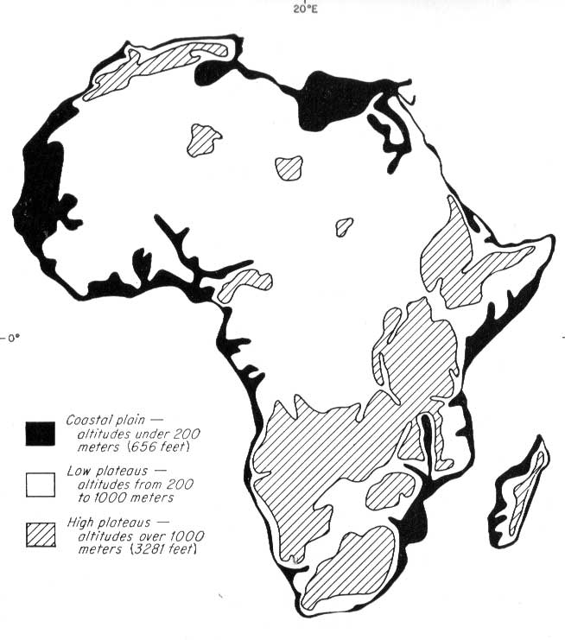**Task**

Write an essay advising the family of Mr. Were Danish on where they can settle and carry out modern animal rearing.

**Part II**

**Item 4. Study the text and Fig 5 provided below to answer the following tasks.**

Over the past decade, Africa's export earnings from Asia, especially for agricultural and industrial products, have increased significantly, according to a 2022 report by the African Development Bank. Many African economists view this as a positive step for economic development. However, some regional politicians argue that these trade statistics are not beneficial for the continent's economic and social development. This disagreement has left many ordinary citizens confused about the implications of increased export earnings.

**Support material**

**2012 2022**

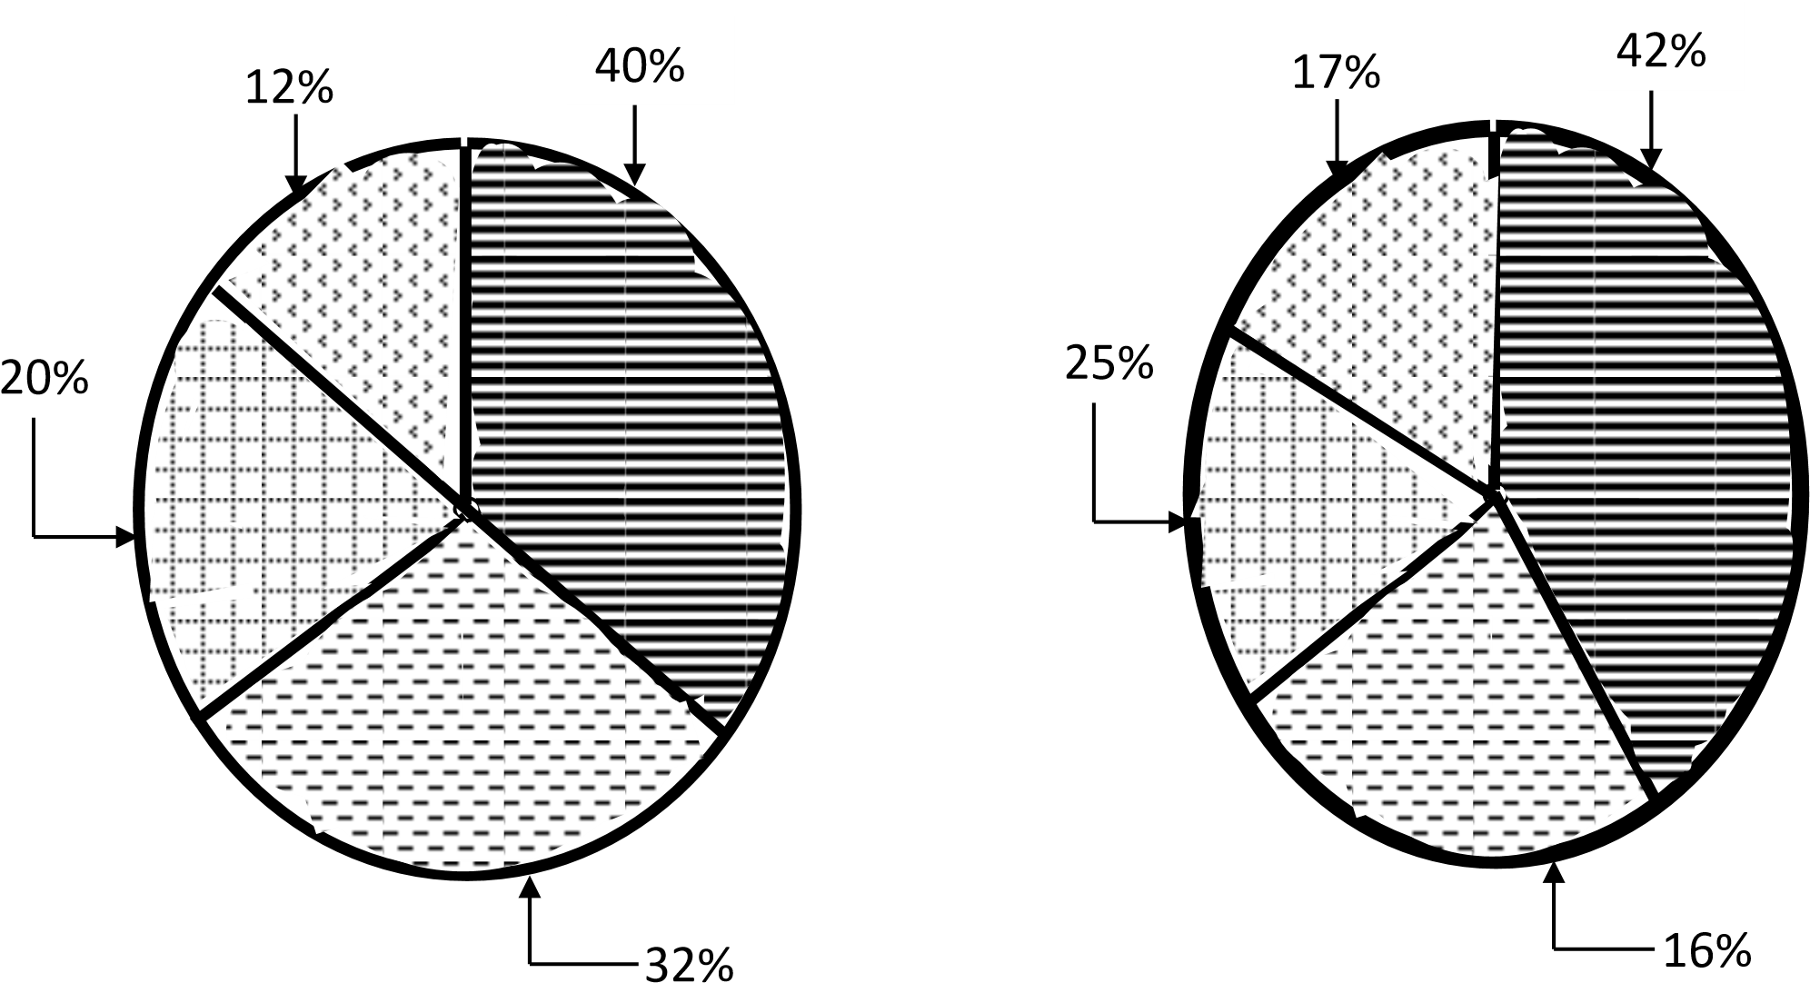

**KEY**

Tourism



Agriculture

Labour

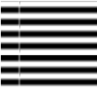

Minerals

**Task:**

1. As a trade observer, explain to NBS Television's audience the points of disagreement between politicians and economists.
2. Provide clear and important facts to help ordinary citizens understand the changes in Africa's export trade.
3. As a geography student, write a detailed message for NBS Television to help African citizens understand the arguments of both economists and politicians.

**END**